ES0 203A INTRODUCTION to EE 17.2.17
TUT6
Q1. A circular coil of 100 turns with mean diameter of 30 Cm is rotated about its vertical axis in earth’s magnetic field at 16 revolutions /sec. Calculate the instantaneous value of the e.m.f. when its plane of rotation is (a) perpendicular to (b) coincident with, the magnetic meridian. Consider the magnetic field (Horizontal component) to be 14.3 AT/m.
Ans: 12.77mV

Q2: A flat coil of 500 turns of fine wire and mean area 600 cm² revolves at a speed of 1600 revolutions per minute in a uniform field having flux density of,80 mWb/m². Calculate the R.M.S. value of the voltage induced in the coil.
Ans: 284.4V

Q3: A d.c machine has four poles of 250Cm² cross-sectional area and an air gap of length 6mm.Each field coil has 1500 turns and the coils are connected in series. Assume that the iron core has infinite permeability. Determine the air gap flux per pole per unit of field current.
Ans: 7.85mWb/A.

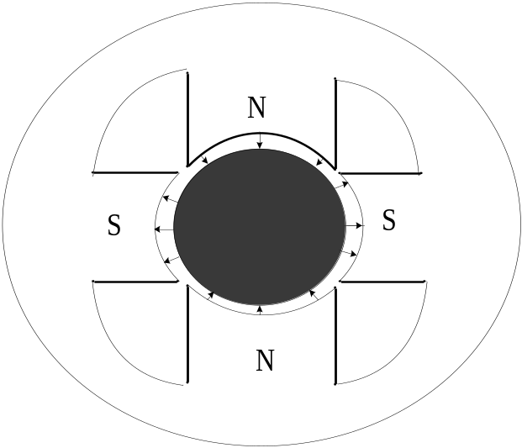

Q4: A d.c generator is driven at a speed of 400 RPM by a suitable prime-mover. It has a flux of 40mWb/pole and 8 poles. The armature winding has 960 conductors.
(i)Calculate the e.m.f. generated on open circuit if winding is lap connected
(ii) If the armature is wave connected, at what RPM it must be rotated to generate 400V?
Ans: (i) 256V,(ii) 156.2RPM

.

